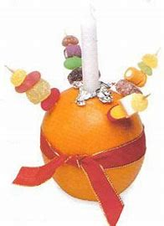
How to make a Christingle.

Fasten a piece of red sticky tape or ribbon around the middle of the orange.
Cut a small cross in the top of each orange (you might need to place it on a plate to catch the juice) and lay a square of silver foil (75mm/3in square) over the cross.
Place a candle on top and wedge it firmly into the orange. The foil will help prevent hot wax running onto a child’s hand.
Put raisins, sultanas, cherries or soft sweets onto 4 cocktail sticks and insert them into the orange as in the picture.
Stand your Christingle on a saucer and take care when you light it.

